Financial Education Program
Date: - 10-01-2022
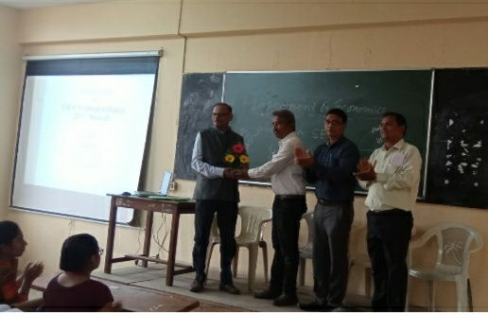
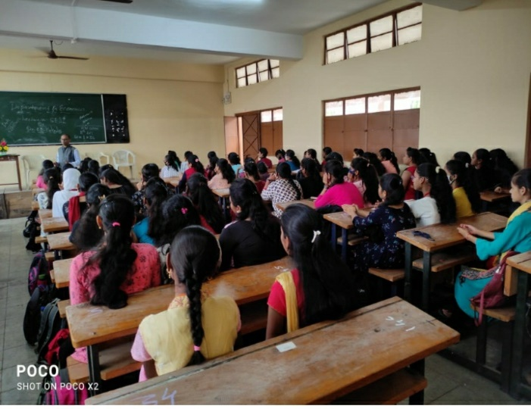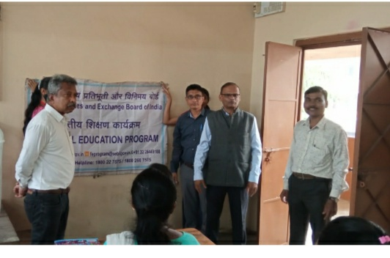
The Security & Exchange Board of India and Department of Economics D.R.K. College of commerce, Kolhapur jointly organized the program on “Financial Education & Investment awareness for students”. The chief guest of this program was Prof. Dr. V. B. Kakade Co-ordinator of Mahaveer Adhysan, Shivaji University, Kolhapur. The president of the program was Prof. B. T. Naik sir, the Introduction was carried out by Prof. Dr. R. S. Naik Sir and proposed vote of thanks Prof. S. F. Bothikar sir all teaching and students were presented in this program.

